INTRODUCTION
As of 2018, 14% and 8% of global oil and gas, respectively, are consumed as feedstock for the chemical industry [IEA 2018]. Out of all the chemicals, ammonia, methanol, ethylene, and propylene are the major building blocks of the chemical industry which are further used as raw materials for the production of valuable products. Ammonia is predominantly produced via the Haber-Bosch process using natural gas as feedstock and is responsible for one-fourth of the total fossil-fuel consumption in the chemical industry [Carlo D’Angelo et al. 2021]. Around 90% of the ammonia produced globally is used for the production of fertilizers. Ammonia alone is responsible for the release of approximately 550 Mt CO₂eq which accounts for 1.5% of global carbon emissions [IEA 2013]. The major source of these emissions is the hydrogen required for ammonia synthesis which is produced via Steam Methane Reforming (SMR) [Carlo D’Angelo et al. 2021]. Similarly, methanol accounts for around 0.3% of global carbon emissions [IEA 2013]. Natural gas or coal is used for the production of syngas which is then converted to methanol via the water-gas shift reaction. This rather simple chemical compound is used for the production of valuable products such as formic acid, acetic acid, dimethyl ether, methylamine, etc. [Mohammed El-Zeftawy 1995].
Ethylene is majorly produced via high temperature (750 – 900°C) steam cracking of hydrocarbons [Kirk Othmer]. It is the world’s largest chemical produced on a volume basis, with a global capacity of 214 Mt (2021) annually [GlobalData]. Steam cracking of hydrocarbons for the production of ethylene yields various by-products such as propylene, butadiene, benzene, etc. Both ethylene and propylene are regarded as the most important olefins as they are used for the production of plastics and resins [Kirk Othmer]. Ethylene and propylene together are responsible for 1.2% of global carbon emissions [IEA 2013]. Therefore, owing to climate change and the targets set by the Paris Agreement, it is important to find alternative ways for the production of these four chemicals which currently account for 3% of the total global carbon emissions [González‑Garay et al. 2021].

In Europe, since July 2021, natural gas which is used as a chemical feedstock for the production of ammonia and methanol has seen a sharp increase in prices. The major reasons for this trend are the impact of COVID, skyrocketing inflation, and geopolitical scenarios that exist today. In the past year, monthly average natural gas prices have increased from 560$ t⁻¹ in July 2021 to 2300$ t⁻¹ as of July 2022 [World Bank]. Similarly, the price of grid electricity has almost quadrupled [Ember]. For Europe, the annual demand is around 19 Mt for ammonia [IEA 2020] and 5 Mt for methanol [Hung Vo et al. 2021, MMSA 2020]. Therefore, increasing natural gas prices and global carbon emissions provide us with a great opportunity to look for alternative routes of production for chemicals and invest in future technologies. In this work, we focus on green routes for the production of ammonia and methanol and compare them with conventional technologies in the present state of affairs.

RESULTS
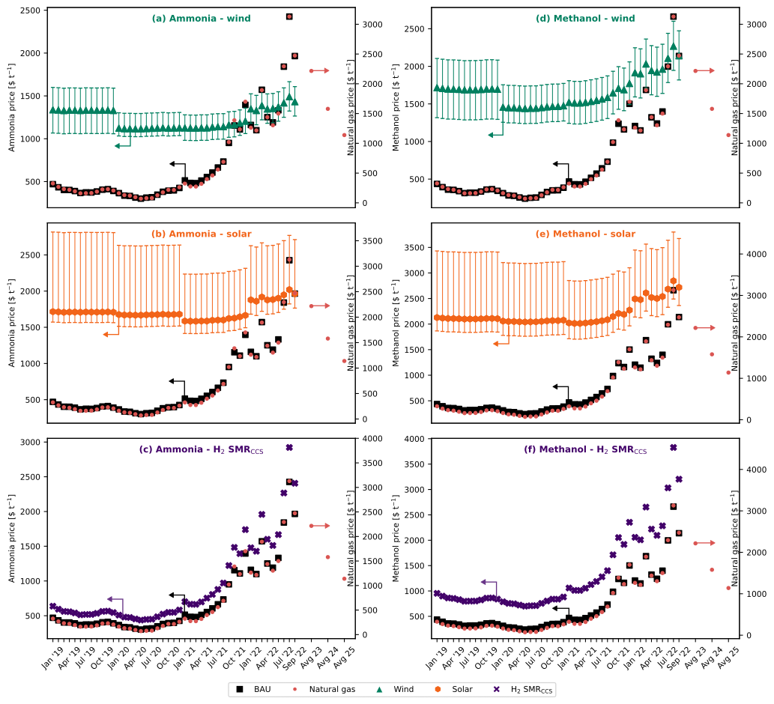
Figure 1. (a) – (c) shows the production cost comparison of fossil (BAU) ammonia vs green ammonia with hydrogen from (a) water electrolysis using on-shore wind electricity, (b) water electrolysis using solar electricity, and (c) SMR + CCS. (d) – (f) shows the production cost comparison of fossil (BAU) methanol vs green methanol with hydrogen from (d) water electrolysis using on-shore wind electricity, (e) water electrolysis using solar electricity, and (f) SMR + CCS. The error bars in plots (a), (b), (d), and (e) are the sensitivity analysis due to the levelized cost of hydrogen (table xx). All the data points are shown in table xx for ammonia and table xx for methanol, respectively.
Cost comparison between the conventional (fossil) and alternative routes of production
Production cost comparison between conventional ammonia and alternative ammonia production routes is shown in Figure 1a – 1c. The material balances and energy flows for both business-as-usual (BAU) or fossil ammonia and alternative production routes are extracted from the work done by Sebastiano et al. 2021. Monthly average natural gas and electricity prices in Europe are shown in table xx. In the case of BAU ammonia, every ton of ammonia produced consumes 0.53 tons of natural gas and 940 kWh of electricity [Sebastiano et al. 2021]. As of September 2022, the cost of production for BAU ammonia was around 1965$ t⁻¹ which is three times higher in comparison to July 2021. Three alternative scenarios for the production of ammonia are considered. The only difference in these three cases is the source of hydrogen. The different sources of hydrogen considered are (Figure 1a) water electrolysis using on-shore wind electricity, (Figure 1b) water electrolysis using solar electricity, and (Figure 1c) SMR + Carbon Capture and Storage (CCS). For all the alternative scenarios, along with hydrogen, nitrogen from cryogenic air separation is used as a feedstock. Whereas, in the case of conventional ammonia, nitrogen comes from the air which is used in the autothermal reactor [Sebastiano et al. 2021].
In Figure 1a, when natural gas prices reach around 1400$ t⁻¹, ammonia with hydrogen from water electrolysis using on-shore wind electricity turns cost-competitive with BAU ammonia. Based on monthly average natural gas prices, ammonia production via wind electrolysis has been cheaper than or similar to BAU ammonia for seven months since October 2021 (table xx). Whereas, for the solar scenario (Figure 1b), ammonia production via this route is only feasible around the peak of natural gas prices (August 2022). This can be attributed to lower capacity factors (16.1% to 17.5%) in comparison to wind electricity (35.6% to 39%) resulting in higher levelized costs of hydrogen [IRENA 2021]. Notably, in the case of both wind and solar, only the electrolyzer uses the respective electricity source, whereas, the production process (compressors) itself uses grid electricity. Ammonia production in the scenario of hydrogen from SMR + CCS is always more expensive than the conventional route due to the inclusion of CCS and also the additional nitrogen feed required in this scenario. In the current state of affairs, natural gas prices are predicted to remain high (1579 – 2216$ t⁻¹) for the next few years. On the contrary, prices of renewable energy technologies are expected to decrease. For that reason, ammonia production from wind could be the most promising technology in the foreseeable future.
Figure 1d – 1f shows the comparison between the production cost of conventional and alternative routes for methanol production. Natural gas is first converted to syngas and then to methanol using the water gas shift reaction in the case of BAU methanol. The material balance and energy flows for BAU methanol and green methanol are extracted from L.A. Pellegrini et al. 2011 and Vázquez et al. 2021, respectively. Every ton of conventional methanol produced consumes 0.67 tons of natural gas and 708 kWh of electricity. Therefore, similar to ammonia, the cost of production for BAU methanol has increased sharply. In comparison to July 2021, the production cost for BAU methanol rose by 232% in September 2022. Following an identical approach to ammonia, three alternative routes for methanol production are considered depending on the source of hydrogen. They are (Figure 1d) water electrolysis using on-shore wind electricity, (Figure 1e) water electrolysis using solar electricity, and (Figure 1f) SMR + CCS. All three alternative routes of production use carbon dioxide from Direct Air Capture (DAC) as a feedstock. Therefore, carbon dioxide and hydrogen undergo the reverse water gas shift reaction to produce syngas, and syngas is converted to methanol in the next step.
In the alternative routes of methanol production, for every ton of carbon dioxide captured, 0.11 tons of natural gas is required. At natural gas prices of around 2475$ t⁻¹, the wind scenario is economically competitive in comparison to BAU methanol (Figure 1d). Also, considering the low prices of wind electricity, at natural gas prices of 1700$ t⁻¹, methanol production via on-shore wind electricity is more feasible than the conventional route. The solar scenario for the production of methanol (Figure 1e) follows a similar trend to that seen for ammonia and is only feasible at the peak of natural gas prices (August 2022) considering the low prices of solar electricity. For the case of hydrogen from SMR + CCS (Figure 1f), the cost of production is on average 67.8% higher than BAU methanol due to the additional cost of CCS and carbon dioxide from DAC. Identical to the case of ammonia, methanol production via wind is expected to be cost-competitive with BAU methanol in the coming future.
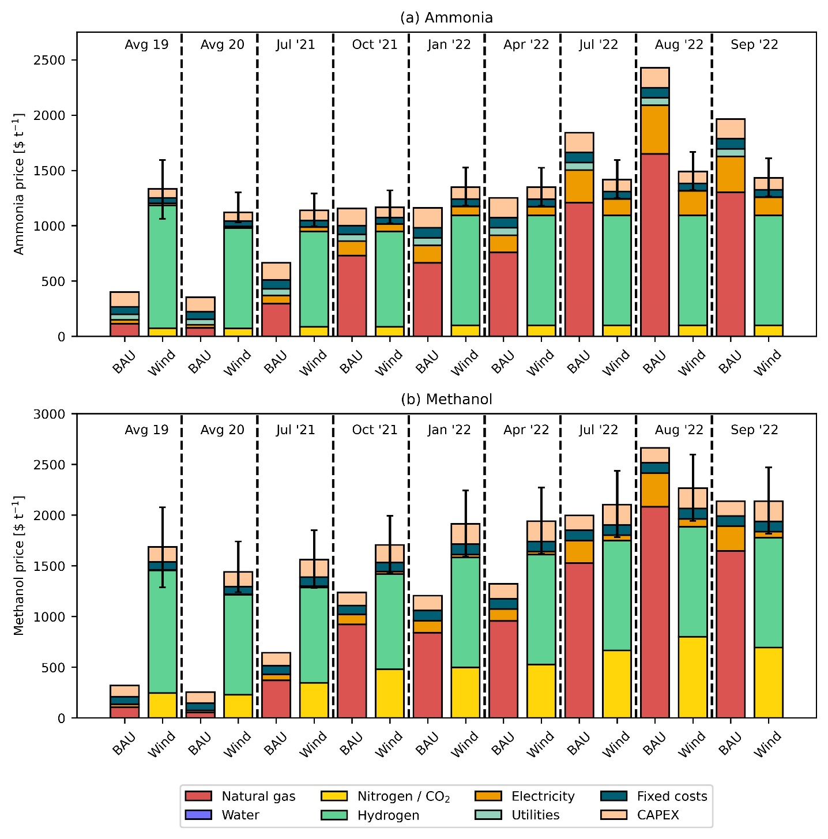
Figure 2. Breakdown of production costs for (a) fossil (BAU) ammonia vs green ammonia with hydrogen from water electrolysis using on-shore wind electricity and (b) fossil (BAU) methanol vs green methanol with hydrogen from water electrolysis using on-shore wind electricity. The error bars are the sensitivity analysis due to the levelized cost of hydrogen (table xx).
Breakdown of production costs for the conventional and wind routes
From Figure 1 we can establish that hydrogen from water electrolysis using on-shore wind electricity for the production of both ammonia and methanol is the most practical alternative compared to the conventional routes of production. To investigate further, Figure 2 shows the breakdown of the production costs for conventional and wind routes of production for ammonia (Figure 2a) and methanol (Figure 2b) in different months. Notably, for the years 2019 and 2020, we take average values for the breakdown calculations as the natural gas and electricity prices before July 2021 were approximately constant (table xx).
For BAU ammonia (Figure 2a), the contribution of natural gas to production costs increased from 21.7% in 2020 (average) to 44.3% in July 2021. Further, the percentage share of natural gas increased to 66.3% in September 2022. Similarly, the contribution of electricity increased from 8.1% in 2020 (average) to 16.5% in September 2022. Green hydrogen from wind electrolysis has the highest share (66.7% to 83.3%) of the production cost for green ammonia (Figure 2a). Since wind electricity is used only for the electrolyzer, whereas for the compressors we utilize grid electricity, the share of grid electricity rose from 1.3% in 2020 (average) to 11.4% in September 2022.
Similarly, for the production of BAU methanol (Figure 2b), the share of natural gas increased from 32.3% in 2020 (average) to 57.8% in July 2021, and 76.9% in September 2022. Whereas, the contribution of electricity increased from 7.2% in 2020 (average) to 11.5% in September 2022. Hydrogen from wind electrolysis had the highest share of around 60.2% in July 2021 which decreased to 50.7% in September 2022 for the green methanol production route (Figure 2b). The share of carbon dioxide from DAC for green methanol production was about 16.5% in 2020 (average) and increased to 32.5% in September 2022. This increase can be attributed to the increase in natural gas prices which is required for the capture of carbon dioxide via DAC (0.11 tons of natural gas per ton of carbon dioxide).
CO₂ avoidance costs
The CO₂ avoidance costs in $ t⁻¹_{CO2eq} are calculated as follows:
$${\text{CO}}_{\text{2}}\text{ avoidance costs [}\frac{\text{\$}}{{\text{t}}_{{\text{CO}}_{\text{2eq}}}^{\text{-1}}}\text{] =} \frac{{\text{P.C}}_{\text{ALT}}\text{ -} {\text{P.C}}_{\text{BAU}}}{{\text{GWP}}_{\text{BAU}}\text{ -} {\text{GWP}}_{\text{ALT}}}$$
where P.C_{BAU/ALT} represents the production cost in $ t⁻¹ for the conventional (BAU) and alternative (ALT) routes. Similarly, GWP_{BAU/ALT} represents the global warming potential in t_{CO2eq} t⁻¹ for the conventional (BAU) and alternative (ALT) routes of production.
In Figure 3, the avoidance costs of all the alternative routes of production considered for ammonia (Figure 3a) and methanol (Figure 3b) are shown. Again, average values are considered for the years 2019 and 2020. It can be seen that the avoidance costs follow an inverse trend to the natural gas price. As natural gas prices increase, we spend less money for every ton of carbon dioxide emissions avoided. Negative avoidance costs signify that the cost of production of BAU ammonia or methanol is higher than the alternative route. As a result, we save money for every ton of carbon dioxide emissions avoided. Since July 2021, we save around 125$ to 638$ per ton of carbon dioxide avoided via the wind route for ammonia production (Figure 3a). Similarly, in August 2022 for methanol via wind, savings stood at around 325$ per ton of carbon dioxide avoided.

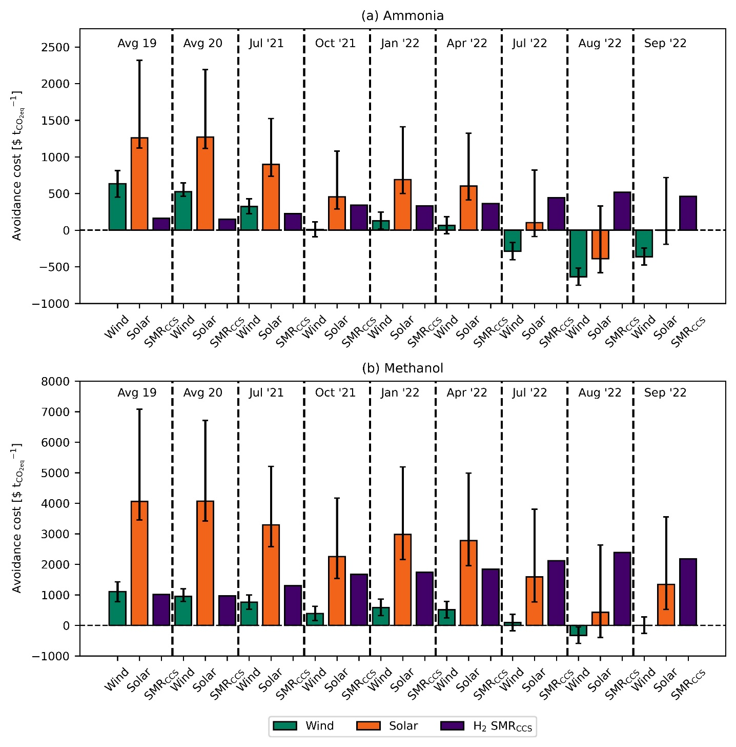
Fig. 3 CO₂ avoidance costs for (a) ammonia, and (b) methanol. The GWP values used are given in table xx and table xx for ammonia and methanol, respectively. The error bars are the sensitivity analysis due to the levelized cost of hydrogen (table xx).

